Circuit Analysis Lab 6
Submitted By:
Shumaim Jameel
Reg. no.
2025-CE-116

EXPLAINATION OF CIRCUITS
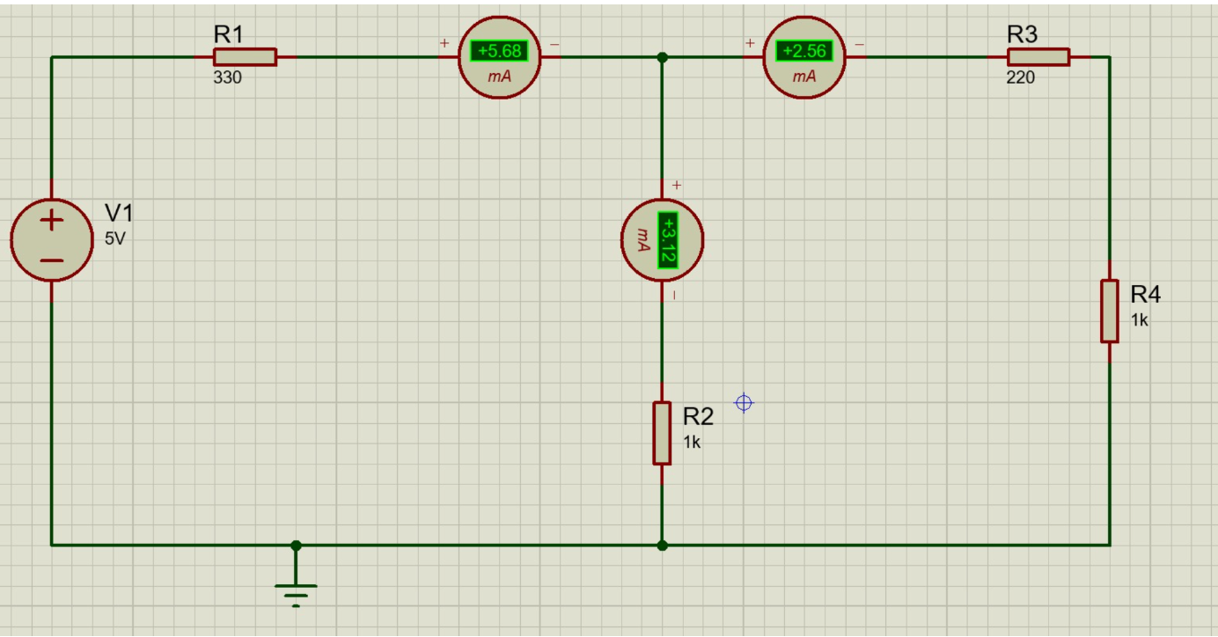

Construction:
- First, take a breadboard or circuit board and gather all the required components such as resistors, DC power supply (RPS), and ammeters.
- Connect the positive terminal of the DC power supply to the circuit.
- Connect a 330 Ω resistor (R1) in series with the positive terminal of the supply.
- After R1, make a junction point where the current will divide into two branches.
- From this junction, connect a 1 kΩ resistor (R2) vertically downwards to the ground (negative terminal of the power supply).
- From the same junction, continue the circuit towards the right and connect a 220 Ω resistor (R3) in series.
- After R3, connect another 1 kΩ resistor (R4) vertically downwards to the ground.
- Connect the negative terminal of the power supply to the common ground line of the circuit.
- Connect an ammeter in series before the junction to measure the total current $I_{1}$.
- Connect another ammeter in the branch containing R2 to measure current $I_{2}$.
- Connect a third ammeter in the branch containing R3 and R4 to measure current $I_{3}$.
- After completing all connections, carefully check the circuit to ensure there are no loose or wrong connections.
- For practical verification, first set the power supply to 5V and note the readings of currents $I_{1}$, $I_{2}$, and $I_{3}$.
- Then increase the supply voltage to 15V and again record all current values.
- Finally, increase the voltage to 25V and take the readings.
- Compare the values and verify that $I_{1}=I_{2}+I_{3}$, which confirms Kirchhoff’s Current Law (KCL).

Circuit 2

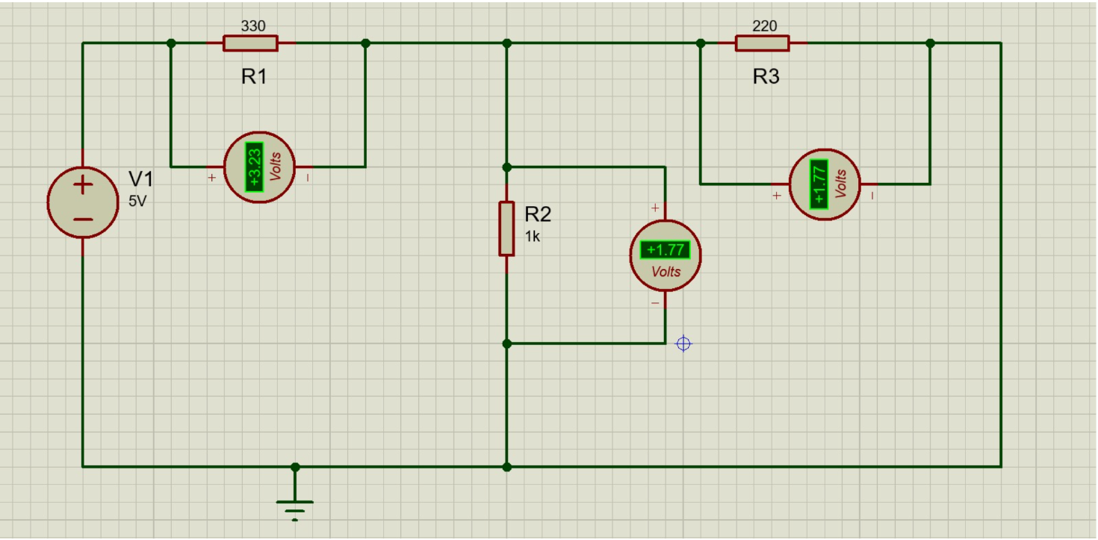

Construction:
- First, take a breadboard or circuit board and collect all required components such as resistors, voltmeters, connecting wires, and a DC power supply (RPS).
- Connect the positive terminal of the DC power supply to the input of the circuit.
- Connect a 330 Ω resistor (R1) in series with the positive terminal.
- Connect a voltmeter (V1) across R1 to measure the voltage drop across it.
- After R1, create a junction point in the circuit.
- From this junction, connect a 1 kΩ resistor (R2) vertically downwards to the ground (negative terminal).
- Connect a voltmeter (V2) across R2 to measure its voltage drop.
- From the same junction, continue the circuit towards the right and connect a 220 Ω resistor (R3) in series.
- Connect a voltmeter (V3) across R3 to measure the voltage drop across it.
- After R3, connect the wire directly downwards to the ground line to complete the loop.
- Connect the negative terminal of the power supply to the ground (common return path).
- Carefully check all connections to ensure correct wiring and avoid loose connections.
- For practical verification, first set the power supply to 5V and note the values of voltages $V_{1}$, $V_{2}$, and $V_{3}$.
- Then increase the supply voltage to 10V and record all voltage readings again.
- Finally, increase the voltage to 15V and take the final readings.
- Compare the values and verify that the supply voltage satisfies $E_{1}=V_{1}+V_{2}$(or loop equation), which confirms Kirchhoff’s Voltage Law (KVL).

